

**UNIVERSITY OF PETROLEUM AND ENERGY STUDIES**

**School of Computer** **Science**

**2020-21**

**GRAPHICS AND ANIMATION TOOLS LAB**

**Faculty: Dr. DURGANSH SHARMA**

**Assistant Professor**

**Department of Cybernetics.**

**School of Computer Science, UPES**

**Submitted By:**

**Name - Vartika Deep**

**SAP ID - 500062441**

**Course - B. Tech CSE (OS&OS)**

**Semester - VII**

**Batch - B3**

**Roll no. - R100217088**

**EXPERIMENT - 10**

**Design of Building using Blender**.

**STEPS:**

**Here, I a creating an old building.**

1. Go to Edit – Preferences - select Images as planes add-on.

2. Add - Image – Images as plane. Select image.

3. Go to view port shading.

4. Select image and rotate along x-axis in 90 degrees and scale it.

5. Go to edit mode. Add loopcuts.

6. Extrude the walls outside and window frames inside.

7. Go to shading.

* Duplicate image texture and in color space select non color. Add color ramp. Add color ramp color with vector and roughness. Duplicate image texture and choose another image. Add math. Connect value to displacement, add its color to vector ,change add to multiply and type -0.2.

8. Go to material and add, add image texture and select image.

9. Add color to base color ,go to edit ,select all the window frames ,click on the material created and click assign.

10. Put roughness down.

11. To add dust particle ,duplicate image texture add image.

12. Go to layout ,duplicate image and rotate it to make the complete building.

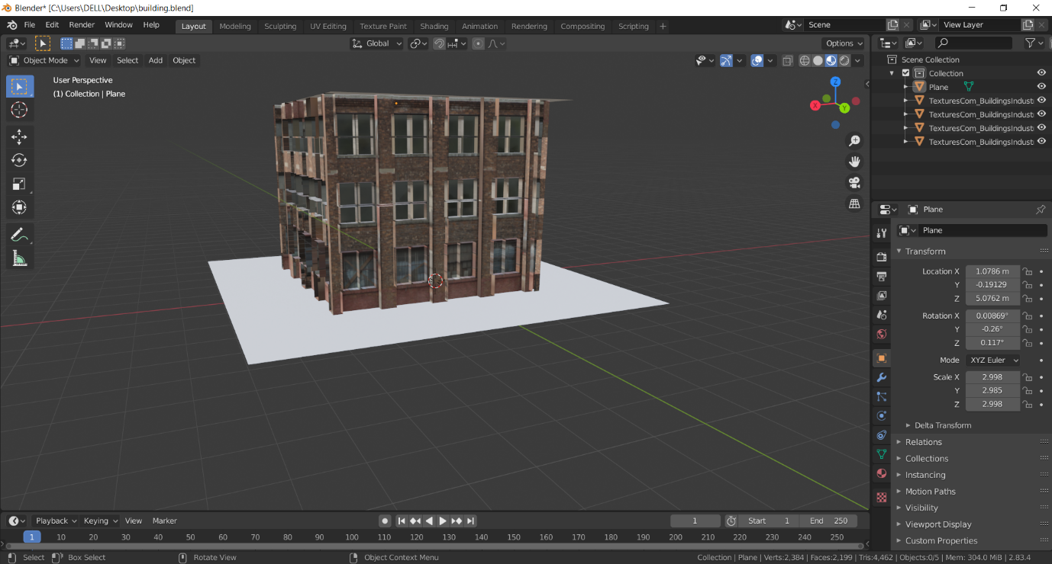

**Link :**

https://drive.google.com/file/d/1YHrFNrmNQZAw_lg2wKOSeglHoUciuFZk/view?usp=sharing